Assignment -1 Basic Commands

1. Commands are actually files containing programs, often written in C. How will you find out in which directory does the file corresponding to the man command resides?

Ans: type man

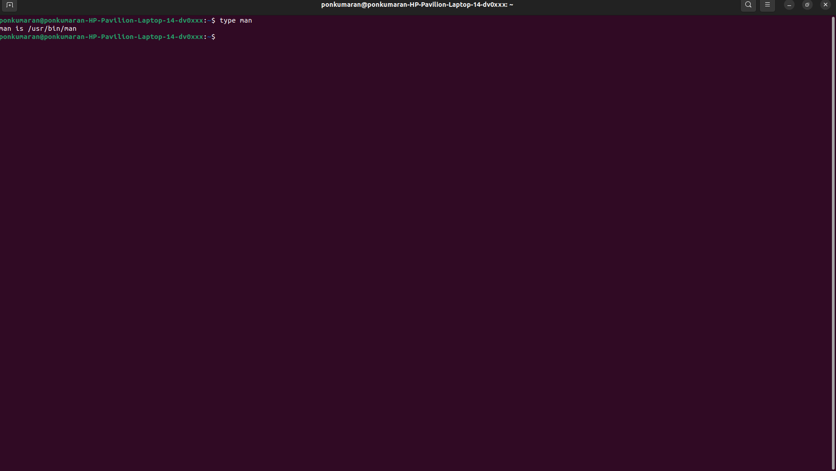

2.How will you find out what is the use of the ps command.

Ans: man ps

